**LEBANESE AMERICAN UNIVERSITY**

**USAID – HIGHER EDUCATION SCHOLARSHIP PROGRAM**

**HES - Volunteering Program Verification Form**

This form is to be used to document volunteering hours. If a student volunteers for multiple organizations, a separate form must be used for each organization. **This form must be turned in by the 28th of each month, the latest.**

I certify that the scholar Joudi Omar completed a total of 10 hours of service at InnovaThrive.

The hours were completed hours as per the below:

Hours # 2 (date) _2/12 – 6/12_ (initials of supervisor) __A.K.___

Hours # 2 (date) _9/12 – 13/12_ (initials of supervisor) __A.K.___

Hours # 4 date) _16/12 – 20/12 (initials of supervisor) __A.K.___

Hours # 2 date) _23/12 - 27/12 (initials of supervisor) __A.K.___

Brief description of the activities the scholar performed or participated in:

As a USAID ambassador, during November and December, I assigned tasks to students, provided them with guidance, and monitored their volunteering hours to ensure that all USAID students at Innovathrive fulfilled their required hours.

Written feedback about the scholar’s performance:

Joudi Omar’s leadership as a USAID ambassador during November and December was impactful. Her dedication to assigning tasks, guiding students, and monitoring their volunteer hours ensured that USAID students at Innovathrive met their goals. Joudi’s organizational and mentorship skills were evident, contributing significantly to the success of the program.

Please rate the overall performance of the scholar at your organization:

|  |  |  |  |
| --- | --- | --- | --- |
|  | Mastery (5) | Proficient (3) | Emerging (1) |
| **Problem solver** | X |  |  |
| **Engaged & Committed** | X |  |  |
| **Open-minded & multicultural** | X |  |  |

Signature

& stamp

__________________________

_

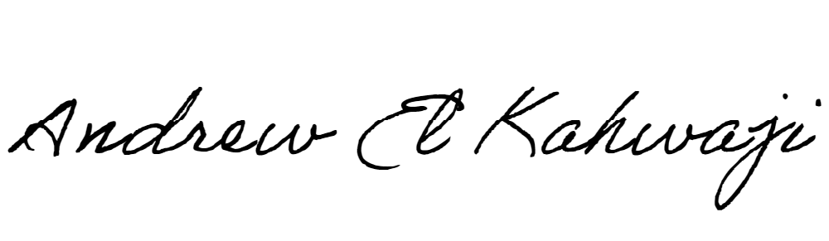

Printed Name _Andrew El Kahwaji_

Date __26/12/2024___

Email __andrew.lifesculptor.coo@gmail.com __

Phone __+961 71 914 378__